# Technical Test 2

Task: To create a Demo Webpage using Arcgis API for JS Version 4.13

Using the Arcgis JavaScript API from Esri, create a single page showing a Basemap with some layers and widgets.

Task 1: Include these 2 layers into the view:

1. Trails layer: https://services3.arcgis.com/GVgbJbqm8hXASVYi/arcgis/rest/services/Trails/FeatureServer/0
2. Parks Layer: https://services3.arcgis.com/GVgbJbqm8hXASVYi/arcgis/rest/services/Parks_and_Open_Space/FeatureServer/0

Basic look should look like this:

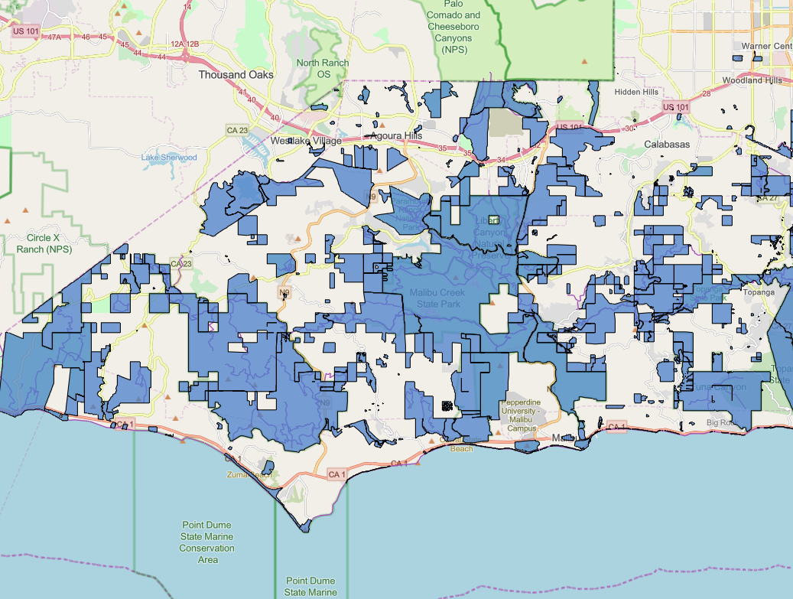

Task 2: Create a Popup Template for the parks layer, showing the reported acre and also half of that area. Example:

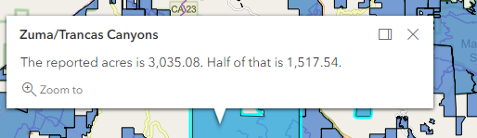

Task 3: Create a simple widget to add:

1. Point

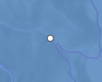

1. Line

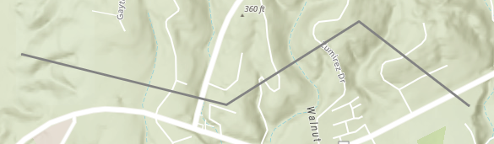

1. Polygon

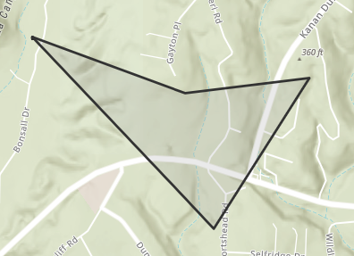

Example:

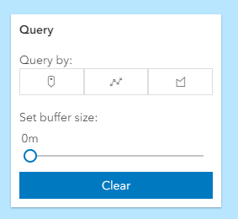

Task 4: Create a buffer to the widget you have added in the previous task

Example:

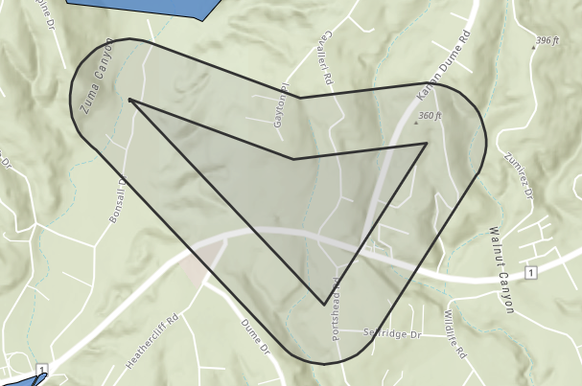

Notes:

1. You may use any of the basemaps hosted by Esri.
2. Try and leave comments in the code for easier understanding.
3. Feel free to add widgets to improve the look and feel of the page.
4. Please zip your project and email it back to us.

Time limit: 1 Hour